***Software Requirement and Design Specifications***

***[SOCIAL MEDIA APPLICATION] (DAYTA)]***

***Version: [1.0]***

|  |  |
| --- | --- |
| *Course Code* | SE2002 |
| *Instructor* | Noureen Fatima |
| *Project Team* | Muhammad Yehya [21K-3309]  Daniyal Haider [21K-3433]  Taha Ahmed [21K-4833] |
| *Submission Date* | 3-Dec-2023 |

***Table of Contents***

1. Introduction 4
   1. .......................................................................................................***Purpose of Document*** 4
   2. ............................................................................................................ ***Intended Audience*** 4
2. Overall System Description 5
   1. .......................................................................................................... ***Project Background*** 5
   2. Project Scope 5
   3. ........................................................................................................................***Not In Scope*** 6
   4. ............................................................................................................. ***Project Objectives*** 6
   5. ....................................................................................................................... ***Stakeholders*** 6
   6. ....................................................................................................***Operating Environment*** 7
   7. .......................................................................................................... ***System Constraints*** 7
   8. .......................................................................................Assumptions & Dependencies 7
3. External Interface Requirements 8
   1. ..........................................................................................................***Hardware Interfaces*** 8
   2. ........................................................................................................... ***Software Interfaces*** 8
   3. ............................................................................................Communications Interfaces 8
4. Functional Requirements 9
   1. ........................................................................................................ ***Functional Hierarchy*** 9
   2. ............................................................................................................................***Use Cases*** 12
5. Non-functional Requirements 14
   1. ............................................................................................ Performance requirements: 14
   2. ..........................................................................................................***Safety requirements*** 14
   3. .................................................................................................... ***Security requirements:*** 15
   4. ......................................................................................................... ***User documentation*** 15

SDS 16

1. System Architecture 17
   1. System Level Architecture 17
   2. Software Architecture 18
2. Design Strategy 19
3. Detailed System Design 19
   1. ................................................................................................................ ***Database Design*** 19
4. Application Design 20
   1. ............................................................................................................ ***Sequence Diagram*** 20
   2. ...................................................................................................... ***Collaboration Diagram*** 21
   3. ......................................................................................................................***State Diagram*** 22
   4. ................................................................................................................. ***Activity Diagram*** 23
   5. .....................................................................................................................***Class Diagram*** 24
5. References 25
6. Appendices 25

## Introduction

### Purpose of Document

This document outlines the essence of our innovative social media application, delineating its functionalities related to user interactions, content creation, and platform management. The primary objectives include:

* User Registration and Account Creation
* Content Posting and Interaction
* Notification Management

### Intended Audience

#### Public Users

#### New users embark on an engaging journey by creating an account, requiring only essential information. Once registered, users gain access to a spectrum of features, enabling seamless content sharing and meaningful social interactions.

#### Management

Our management team oversees the platform's operational aspects, ensuring a smooth user experience, handling notifications, and addressing unexpected scenarios. They play a pivotal role in maintaining a vibrant and secure social environment.

#### Developers

Developers are the frequent active users of this system because they have to implement every single change in the system any update in the system. They also manage the User Interface (UI) of the system.

## Overall System Description

### Project Background

In the ever-evolving landscape of digital communication, the need for a dynamic and user-centric social media platform has become increasingly apparent. The existing platforms may not fully encapsulate the diverse range of social interactions and expressions users seek. This void, coupled with the evolving nature of online social dynamics, has inspired the creation of our social media application.

### Project Scope

The main purpose of our system is to facilitate seamless and efficient social interactions within a digital environment. It encompasses user profiles, real-time updates, content sharing, and personalized features. The system is designed to cater to a diverse range of user preferences and communication styles. We have designed the system to perform these tasks:

* User discovery
* Content sharing
* Interactive features
* Privacy control

### Not In Scope

This application is currently not available on smartphones but is available in personal computers (website) and laptops only..

### Project Objectives

Our social media platform endeavors to not only eliminate the drawbacks of existing systems but also provide users with a sophisticated and user-friendly environment. The introduction of automation, error reduction measures, and enhanced security aims to revolutionize the social media experience, setting new standards for efficiency, reliability, and user satisfaction.

### Stakeholders

* Public Users
* Platform Administrator
* Content Creators
* Data Security Experts
* Developers

### Operating Environment

This system operates on web browsers only.

“DAYTA” this social media application shall work on only PC’s and laptops. Internet is required to run this application.

The Hardware Configuration including:

* CPU: 1.3 GHz Dual-Core or above.
* RAM: 512 MB minimum,
* 4GB built-in memory.
* Only support keypad Devices.

### System Constraints

#### Cultural Constraints

Given the diverse user base of the social media application, language plays a crucial role in fostering inclusive interactions. The primary language used in the application is "English" to ensure universal understanding among users.

#### Legal constraints

Operating under the jurisdiction and regulations of relevant authorities, this social media application is committed to ensuring the utmost privacy and data security for its users. Adherence to privacy laws and guidelines is paramount, protecting users from data breaches and unauthorized third-party access. The application operates within the legal framework set by the respective government, upholding the highest standards of user data protection.

### Assumptions & Dependencies

The first assumption is that users must have access to a web browser on their devices like computer system, to effectively utilize our social media application. Internet access is required for seamless interaction.

• Admin personnel are assumed to have comprehensive knowledge of the social media platform's functionalities to effectively manage and moderate the system.

• Users are required to be logged into the system with a valid username/password through web browsers to access and utilize various features of the social media application.

## External Interface Requirements

### Hardware Interfaces

This application is optimized for use on various devices with web browser support. It is compatible with a wide range of hardware, including desktop computers, laptops, tablets, and mobile devices, eliminating the need for specific hardware requirements.

### Software Interfaces

For the web-based application, users need a device with a modern web browser. The application is designed to be compatible with popular browsers such as Google Chrome, Mozilla Firefox, Safari, and Microsoft Edge. It operates seamlessly on any operating system that supports these browsers.

### Communications Interfaces

The application primarily communicates through standard web protocols. It leverages HTTP/HTTPS protocols for secure and efficient data transfer between users and the server. As a web-based platform, it doesn't rely on Wi-Fi-Direct but utilizes standard internet connectivity. Additionally, the application communicates with the database to manage user details, ensuring a reliable and secure exchange of information within the system.

## Functional Requirements

### Functional Hierarchy

* + 1. ***Use Case Diagram:***

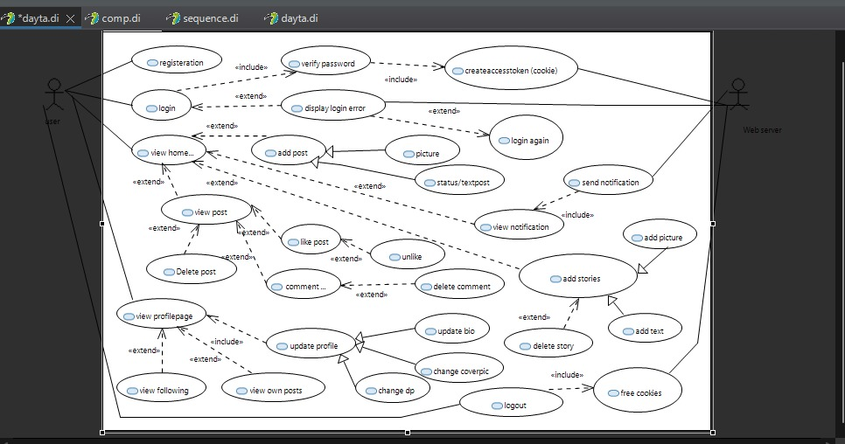

### Use Cases

|  |  |
| --- | --- |
| **Use Case ID** | **AppUC1** |
| **Use Case Name** | **Login Or Register** |
| **Actor** | User |
| **Description** | Register or Login the user into the system |
| **Trigger** | User starts application |
| **Precondition** | The user has downloaded the Application |
| **Post condition** | The user has logged in successfully |
| **Normal Flow** | 316. User clicks on the application.  427. User clicks on Login  853. User enters ID and password  496. System verifies ID and password  7510. . System gives confirmation to the user |
| **Alternative Flow** | 61.1. User clicks on the application 2712. . User clicks on Register  8313. . Enters ID and password  4914. . System validates ID and password  515.0. System gives confirmation to the user |
| **Exception** | Invalid ID or password |
| **Include** | None |

|  |  |
| --- | --- |
| **Use Case ID** | **AppUC2** |
| **Use Case Name** | **Create Post** |
| **Actor** | User |
| **Description** | The user interacts with various features of the social media application. |
| **Trigger** | The user logged in successfully |
| **Precondition** | The user is registered on the social media platform. |
| **Post condition** | The user has accessed at least one feature |
| **Normal Flow** | 1. User navigates to the platform's home page. 2. User explores and interacts with various content in the feed. 3. User engages with posts by liking and commenting. 4. User posts new content. 5. User checks and responds to notifications. |
| **Alternative Flow**  **1** | 1. User navigates to a specific user's profile. 2. User explores and interacts with the content on that profile. |
| **Alternative Flow**  **2** | 1. User accesses the messaging feature. 2. User sends and receives private messages. |
| **Exception** | In the event of a technical error or invalid input during any of the above actions, the system will prompt the user with an appropriate error message. |
| **Include** | Web server  Internet access  User profile |

|  |  |
| --- | --- |
| **Use Case ID** | **AppUC3** |
| **Use Case Name** | **Update/View profile** |
| **Actor** | User |
| **Description** | The user accesses and updates their profile information on the social media application. |
| **Trigger** | The user has successfully logged into the system |
| **Precondition** | User is registered |
| **Post condition** | The user's profile information, including profile picture, cover photo, and bio, has been updated. |
| **Normal Flow** | 1. User navigates to their profile section. 2. User views the current profile picture, cover photo, and bio. 3. User selects the option to update profile information. 4. User uploads a new profile picture. 5. User changes the cover photo. 6. User edits and updates the bio. 7. User saves the changes. |
| **Alternative Flow** | If the user decides not to make any changes, they can exit the update profile section without saving. |
| **Exception** | In case of technical errors during the update process, the system will prompt the user with an appropriate error message. |
| **Include** | None |

|  |  |
| --- | --- |
| **Use Case ID** | **AppUC4** |
| **Use Case Name** | **Like/Comment post** |
| **Actor** | User |
| **Description** | The user engages with posts by liking or commenting on the social media application. |
| **Trigger** | The user is logged into the system and views a post on the feed. |
| **Precondition** | The user is registered on the social media platform. |
| **Post condition** | The user's like or comment has been successfully added to the post. |
| **Normal Flow** | 1. User scrolls through the feed and views a post. 2. User clicks on the "Like" button to express approval. 3. User types a comment in the comment box. 4. User clicks the "Comment" button to post the comment. |
| **Alternative Flow** | 1. User clicks on an existing comment to reply to it. 2. User types the reply and clicks the "Reply" button. |
| **Exception** | * In the event of a technical error or server issue during the liking or commenting process, the system will prompt the user with an appropriate error message. |

## Non-functional Requirements

### Performance requirements:

* The social media platform should efficiently handle a large number of concurrent users and transactions, providing a seamless user experience without performance degradation or downtime.
* The platform should exhibit quick response times to user requests, ensuring that interactions such as posting, liking, and commenting are processed swiftly, and enhancing user engagement.
* Continuous availability is crucial, and the platform should be accessible to users at all times, minimizing downtime and interruptions to user interactions.
* Compatibility across various devices and operating systems is essential, allowing users to access the social media platform seamlessly from different platforms and devices.
* The platform should robustly handle a substantial volume of interactions, ensuring that users can engage with content, post updates, and connect with others efficiently.
* Resilience to failures is paramount; the platform should swiftly recover from any technical issues or errors, maintaining a consistent and reliable user experience.
* The social media platform should undergo regular performance monitoring and evaluation, with proactive updates and improvements implemented to ensure optimal performance and user satisfaction.

### Safety requirements

* The social media platform should enforce secure and unique user authentication, requiring users to log in with a robust username and password. Authorization checks must be in place to ensure users access only authorized data.
* To safeguard user privacy, all user data and financial transactions should be encrypted, mitigating the risk of unauthorized access and data theft.
* Robust measures, including access controls, data encryption, and regular backups, should be implemented to protect user data from unauthorized access, modification, or destruction, ensuring the integrity and confidentiality of user information.
* The platform must have a comprehensive disaster recovery plan, enabling the restoration of critical data and systems in the event of a security breach, natural disaster, or unforeseen circumstances. This plan should be regularly tested and updated to ensure its effectiveness and responsiveness to unexpected events.

### Security requirements:

* The social media platform must implement a robust access control system, restricting access to sensitive data and functions exclusively to authorized users.
* Regular vulnerability assessments must be conducted on the platform to proactively identify and address security weaknesses in a timely manner, ensuring a resilient defense against potential threats.
* An incident response plan is imperative, delineating clear procedures for addressing security incidents, minimizing their impact, and swiftly restoring normal operations.
* The platform should adhere to secure coding practices, including but not limited to input validation, error handling, and parameterization, to mitigate common vulnerabilities such as SQL injection and cross-site scripting (XSS). These practices contribute to the overall security posture of the social media platform, safeguarding against potential exploits and unauthorized access.

### User documentation

* Tutorials to provide users with interactive and engaging resources that guide them through specific tasks or processes in the application.
* A glossary that provides a list of key terms and definitions used in the application, helping users understand the terminology used in the application.
* FAQs to provide answers to commonly asked questions about the application, such as how to make a booking, how to cancel a booking, or how to reset a password.

# SDS

## System Architecture

### System Level Architecture

* User Management: Oversees user registration, login, and profile management, ensuring a seamless onboarding experience and personalized user interactions within the social media platform.
* Navigation & Interface: Manages the user interface and navigation elements, providing an intuitive and engaging experience for users as they explore and interact with various features on the social media application.
* User Content Handling: Displays and manages user-generated content, including posts, images, videos, and stories, ensuring efficient content delivery and interaction capabilities.
* Interaction Processing: Facilitates user interactions such as liking, commenting, and sharing, as well as managing privacy settings and notifications, contributing to a dynamic and responsive social media experience.
* Integration Modules: Incorporates external modules like Customer Relationship Management (CRM) systems and External Data APIs to enhance functionality and connectivity, enabling seamless integration of additional features and data sources within the social media platform.

### Software Architecture

* + 1. ***Component Diagram***

***Components****:*

* *User Management*
* *Interface & Navigation*
* *User Content Handling*
* *Interaction Processing*
* *Integration Modules (CRM, External Data API)*

***Relationships****:*

* *User Management governs user access and authentication.*
* *Interfaces provide access to various pages and features within the social media platform.*
* *Interaction Processing manages user engagement, including likes, comments, and notifications, and interacts with User Content Handling.*
* *Integration Modules facilitate communication with external systems, incorporating CRM and External Data APIs for additional functionality and data exchange.*

***External Interfaces****:*

* *Utilizes CRM and External Data API for seamless data exchange, enhancing the platform's capabilities and integration with external services.*

***Physical Design:***

* *Hosted on reliable cloud servers to ensure scalability and optimal performance, accommodating the dynamic and evolving nature of social media interactions.*

***Global Strategies:***

* *Implements robust error handling mechanisms to enhance system stability and provide a resilient user experience, addressing potential issues and maintaining platform reliability.*

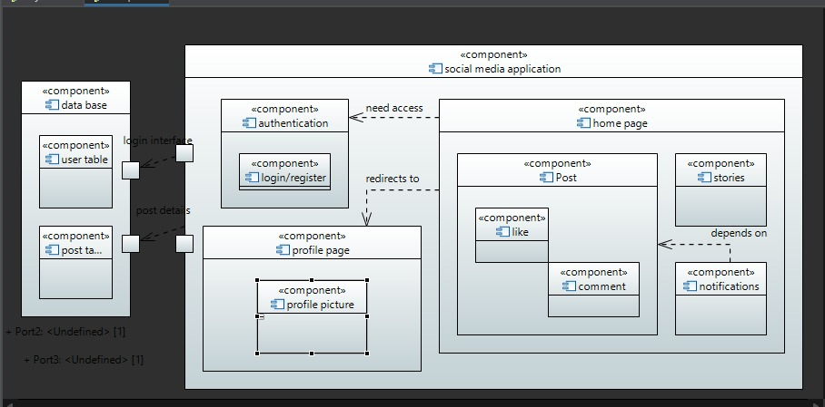

## Design Strategy

* User-Centric Design:
* Prioritize a user-centric approach, ensuring the application is intuitive, easy to navigate, and offers a seamless user experience. Regularly gather user feedback to inform design updates and enhancements.
* Responsive and Accessible Design:
* Implement a responsive design to cater to users across various devices and screen sizes. Additionally, adhere to accessibility standards to ensure inclusivity for users with diverse needs.
* Modular and Scalable Architecture:
* Adopt a modular design approach to facilitate easier maintenance and updates. Develop a scalable architecture that accommodates growth and additional features while maintaining system performance.
* Personalization and Customization:
* Integrate features that allow users to personalize their experience, including customizable profiles, preference settings, and content curation, fostering a sense of individuality.
* Robust Security Measures:
* Prioritize the implementation of robust security protocols, including encryption, secure authentication, and proactive monitoring, to safeguard user data and privacy.
* Seamless Integration with External Services:
* Design with flexibility in mind to seamlessly integrate with external services and APIs, allowing for the incorporation of new features, partnerships, and data sources.

## Detailed System Design

### Database Design

### ER Diagram

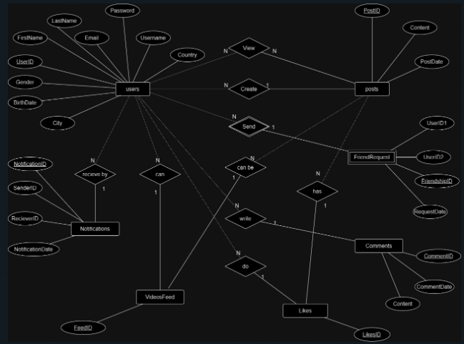

* + 1. ***Data Dictionary*** *Not Applicable*

## Application Design

### Sequence Diagram

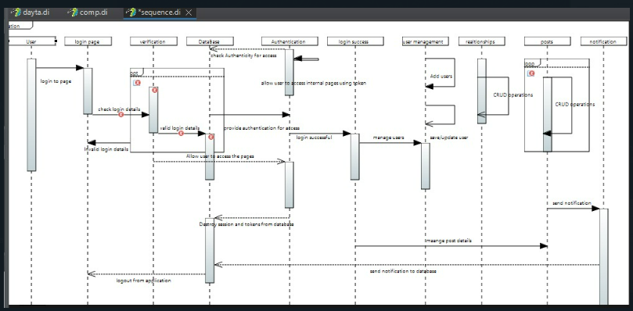

### Collaboration Diagram

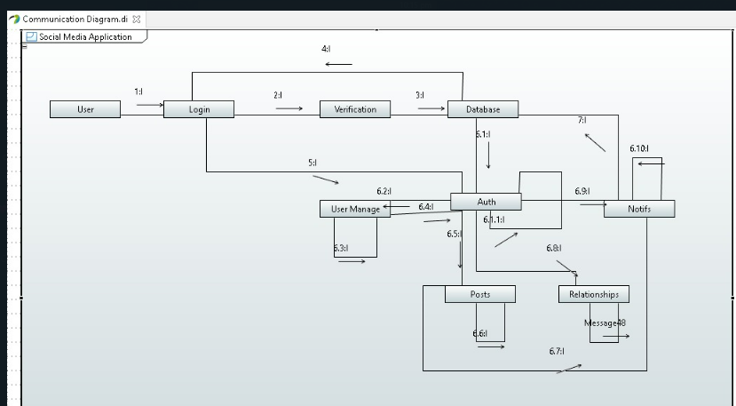

### State Diagram

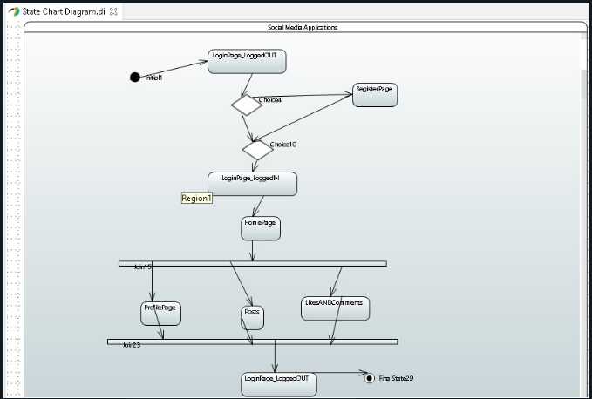

### Activity Diagram

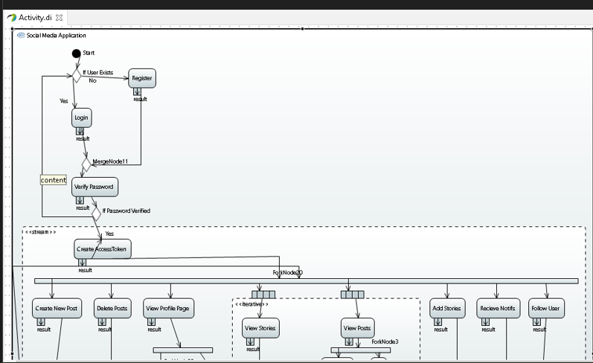 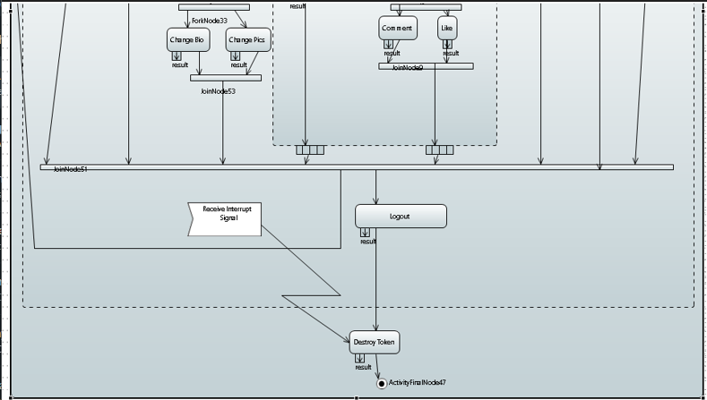

### Class Diagram

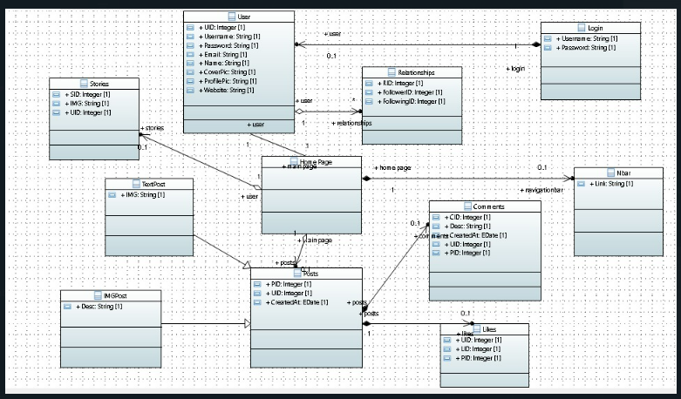

### Timing Diagram

### 

### 9.7: ECB Diagram

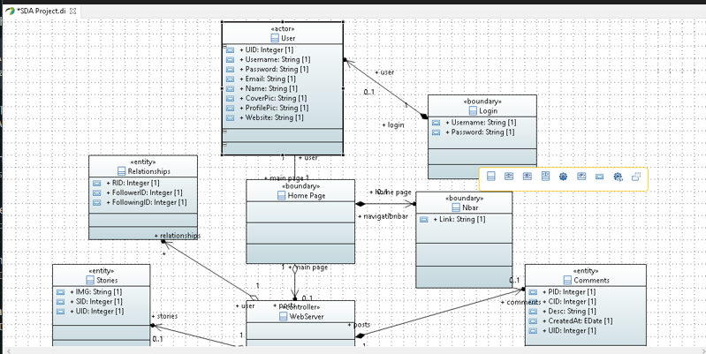

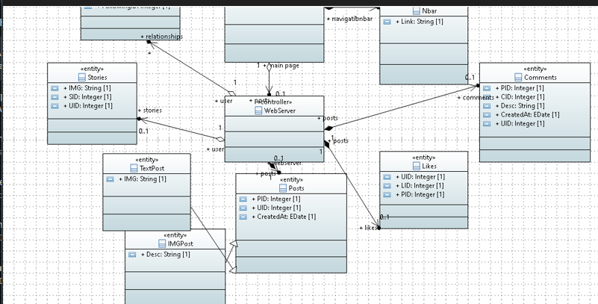

## 1.References

## 2.Appendices

1. **Technical Specifications:**
   * Hardware Specifications:
     + Server Configuration:
       - Processor: Intel Xeon E5-2670 (2.60GHz, 8 cores)
       - Memory: 8GB RAM
       - Storage: 250GB SSD
     + Networking Infrastructure:
       - Bandwidth: 1 Mbps
       - Firewall: Sophos XG Firewall
   * Software Specifications:
     + Operating System: Ubuntu Server 20.04 LTS
     + Web Server: Apache 2.4
     + Database: MySQL 8.0
2. **Glossary**:
   * Definitions of Technical Terms:
     + User Registration: Process of creating a new user account in the system.
     + Authentication: Verifying the identity of a user during login.
     + Transaction Processing: Handling user transactions, such as purchases, within the system.